React Lab-1:
Create a new React Application with the name “myfirstreact”, Run the application to print “welcome to the first session of React” as heading of that page.
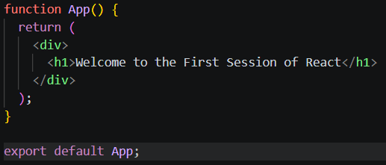
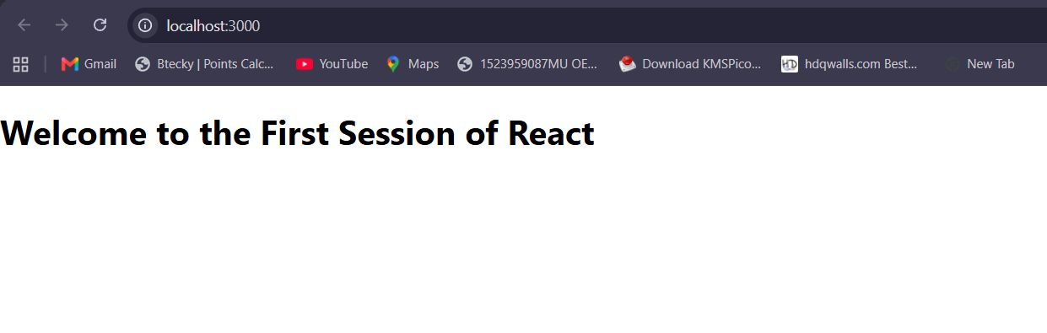

React Lab-2:
Create a react app for Student Management Portal named StudentApp and create a component named Home which will display the Message “Welcome to the Home page of Student Management Portal”. Create another component named About and display the Message “Welcome to the About page of the Student Management Portal”. Create a third component named Contact and display the Message “Welcome to the Contact page of the Student Management Portal”. Call all the three components.

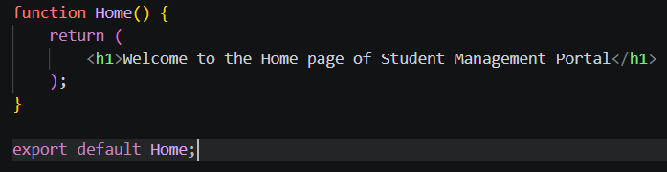
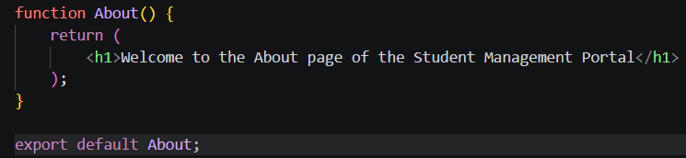
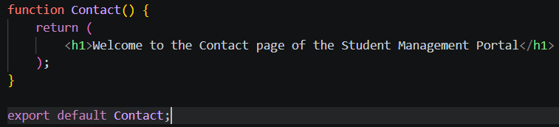
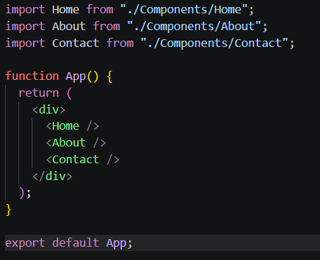
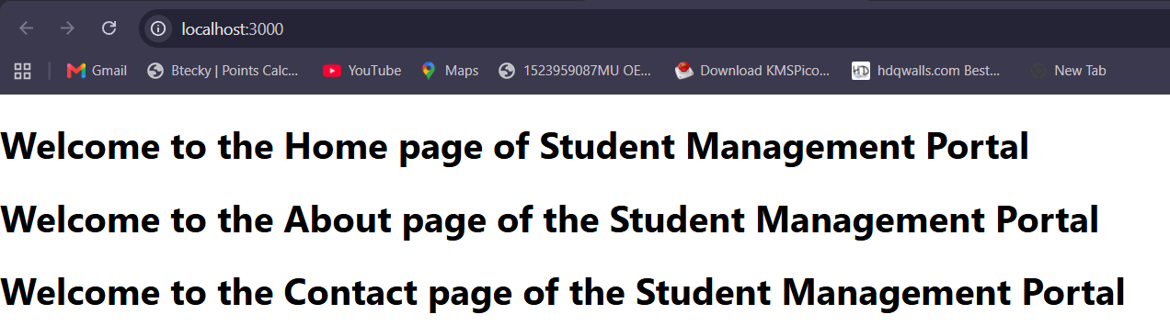

React Lab-3:
Create a react app for Student Management Portal named scorecalculatorapp and create a function component named “CalculateScore” which will accept Name, School, Total and goal in order to calculate the average score of a student and display the same.
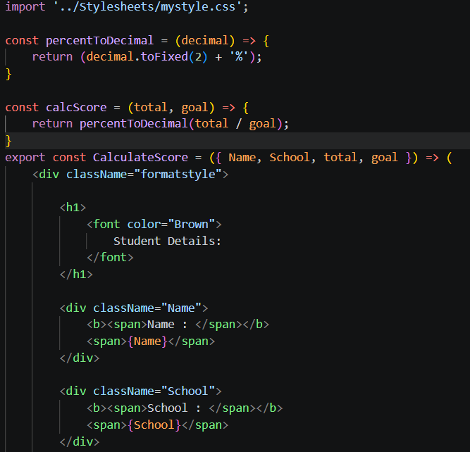
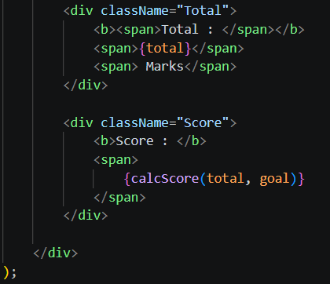

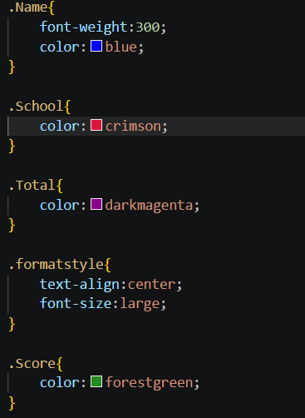
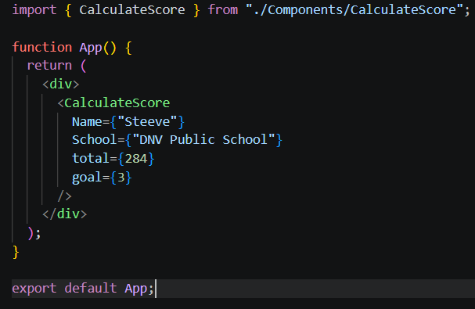
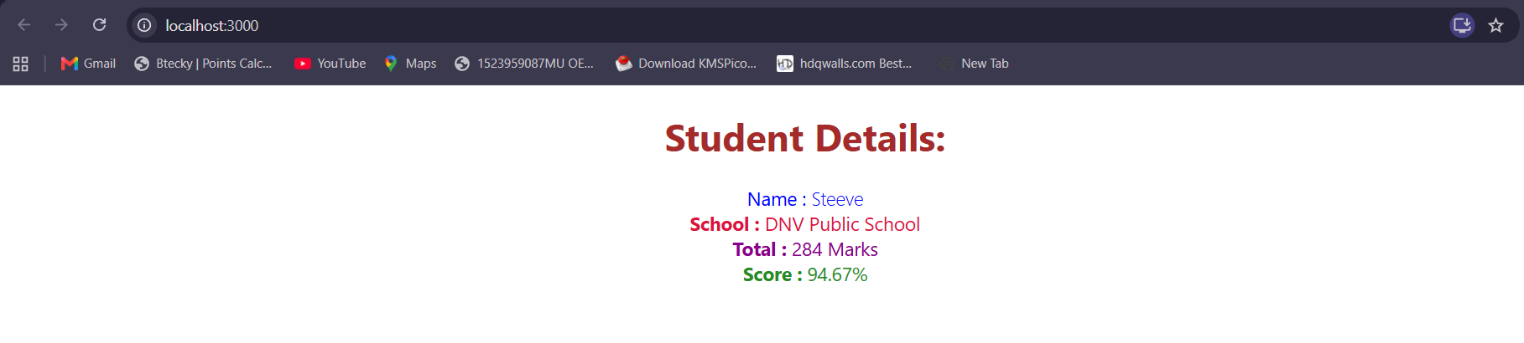

React Lab-4:
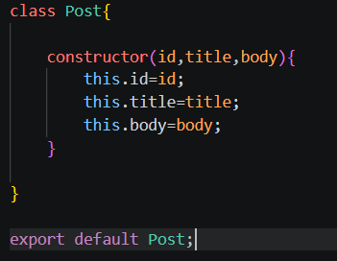
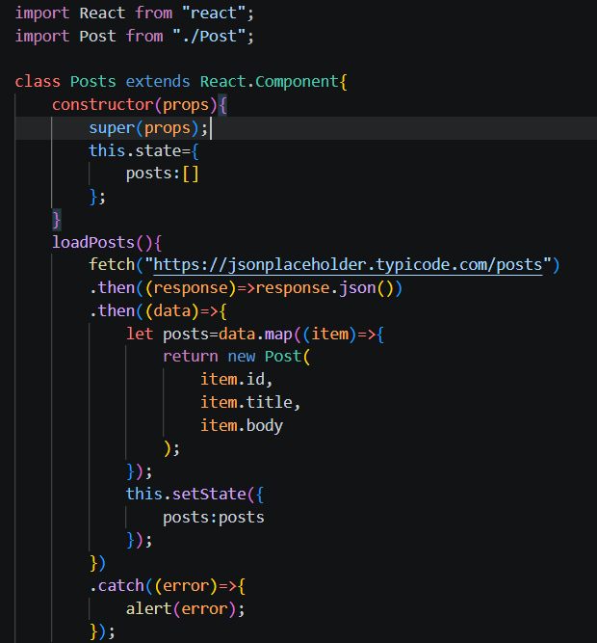
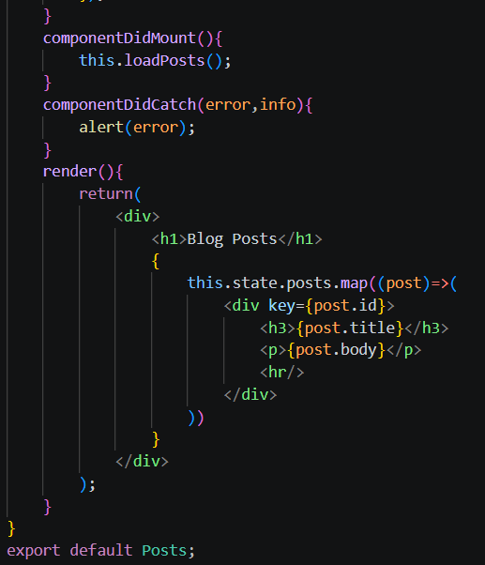
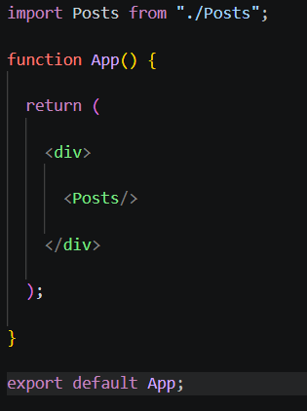
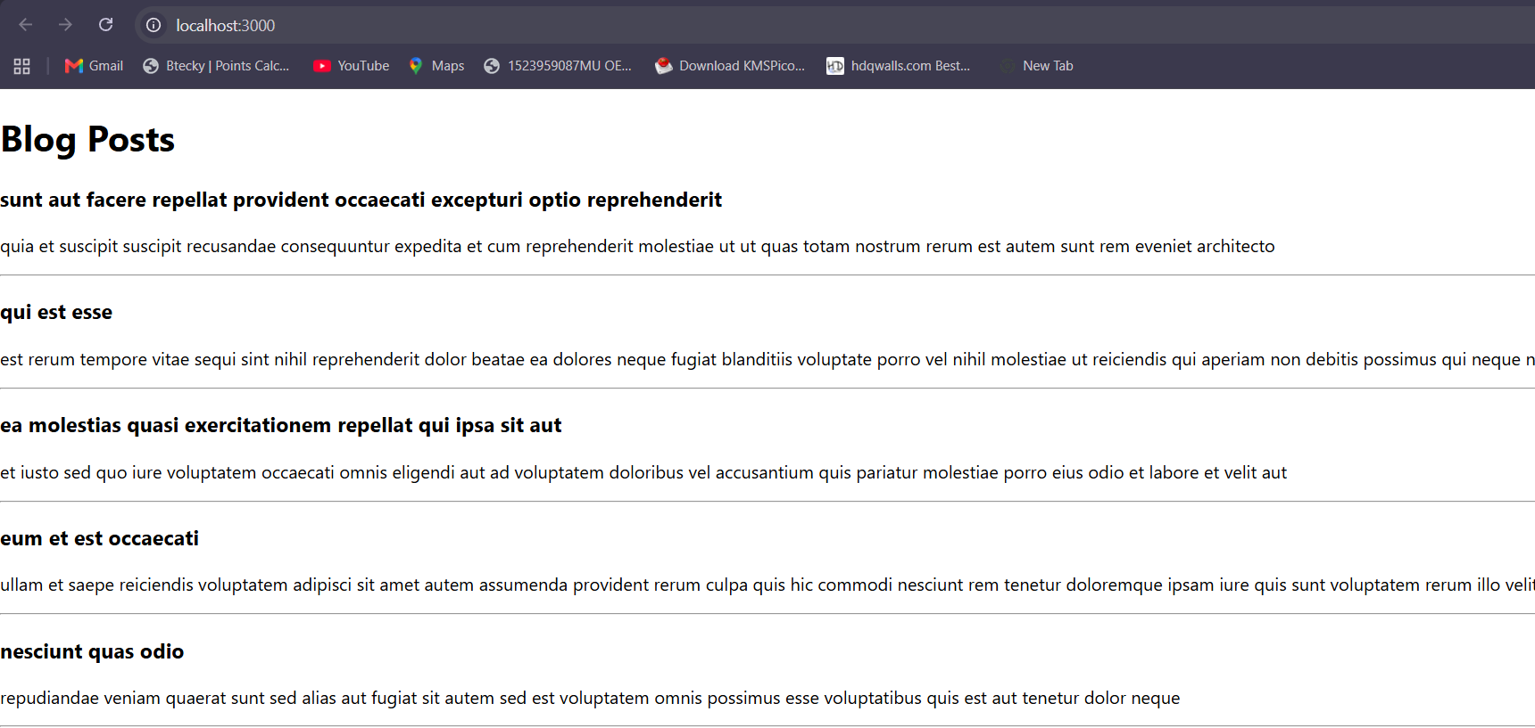
React Lab-5:
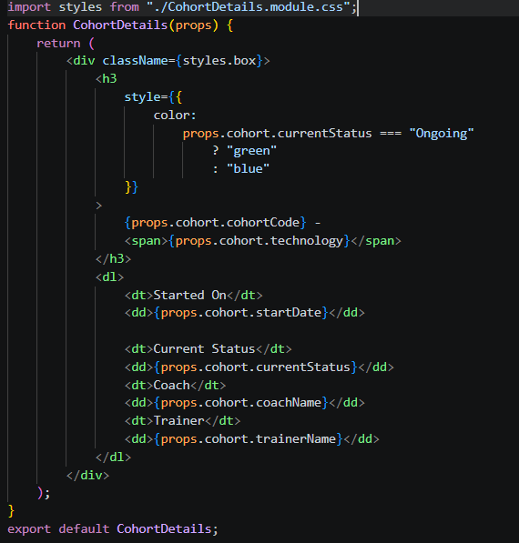
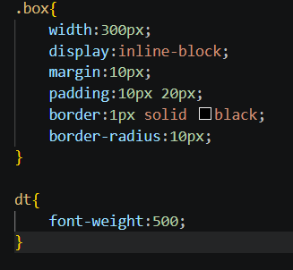
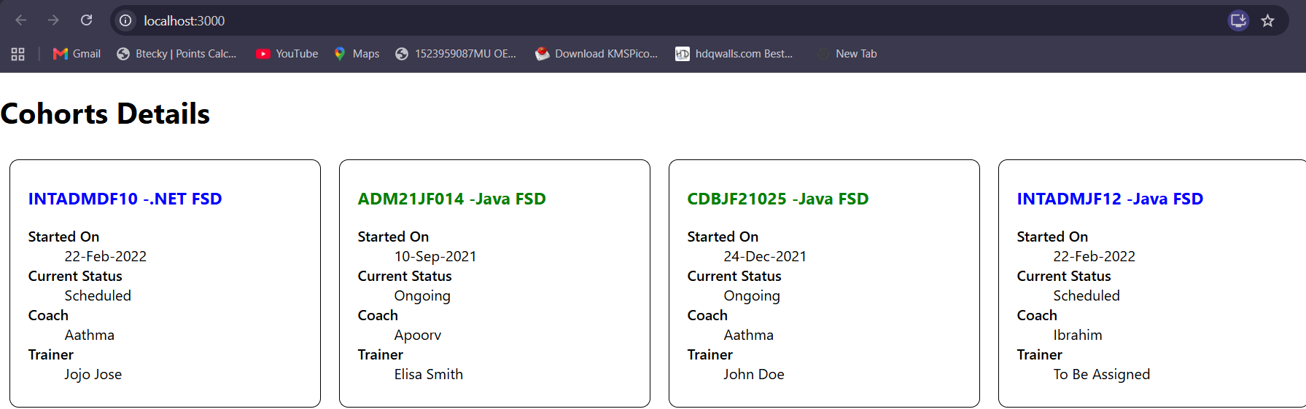

React Lab-9:
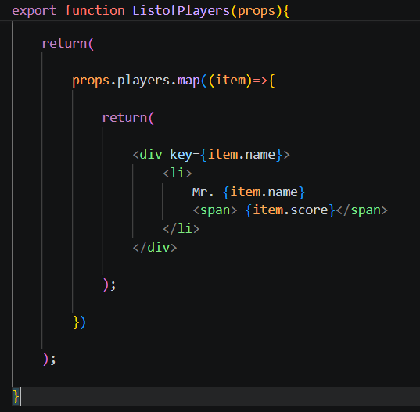
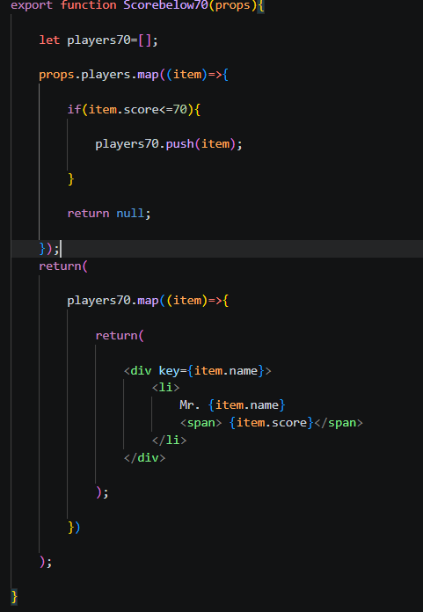
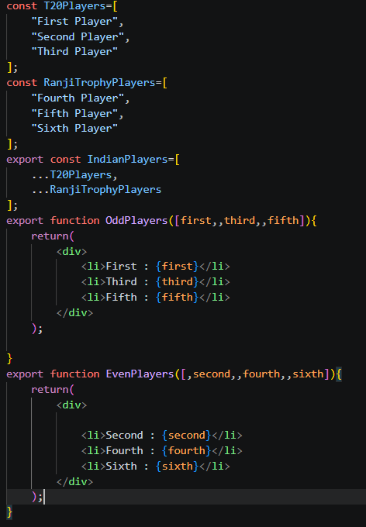
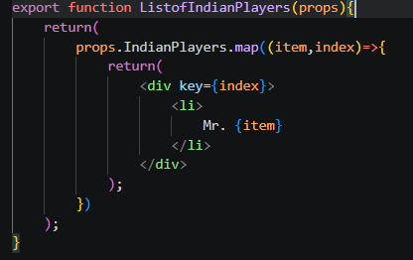
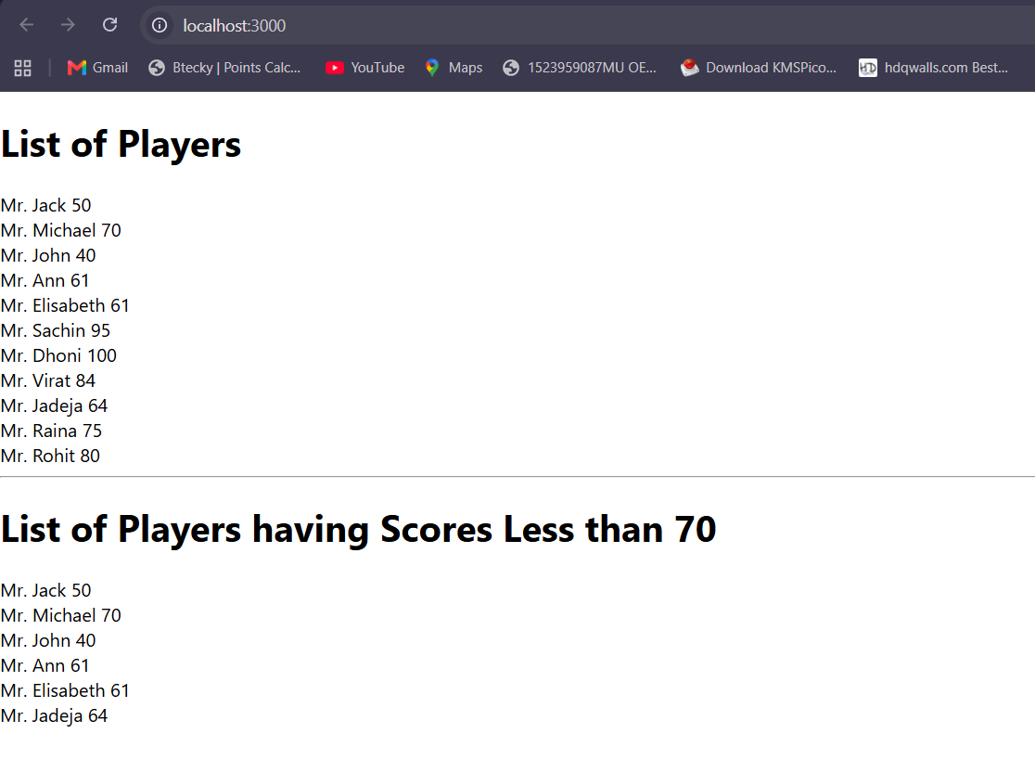

React Lab-10:
Create a React Application named “officespacerentalapp” which uses React JSX to create elements, attributes and renders DOM to display the page.
Create an element to display the heading of the page.
Attribute to display the image of the office space
Create an object of office to display the details like Name, Rent and Address.
Create a list of Object and loop through the office space item to display more data.
To apply Css, Display the color of the Rent in Red if it’s below 60000 and in Green if it’s above 60000.

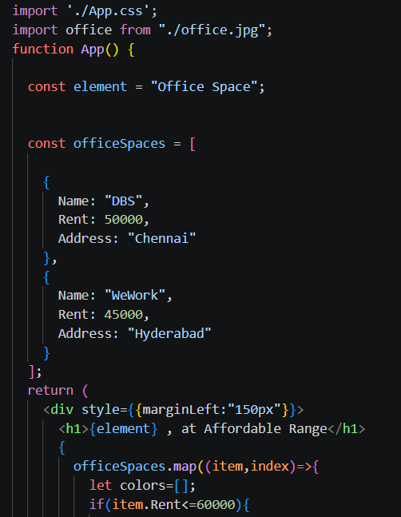
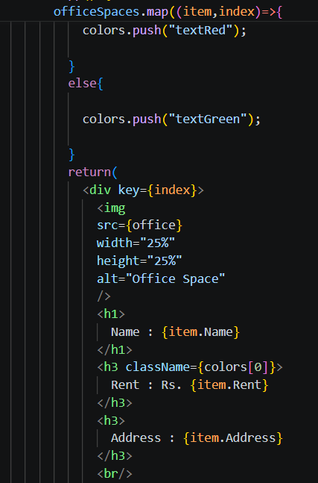
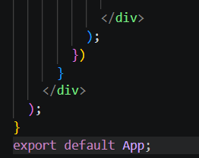
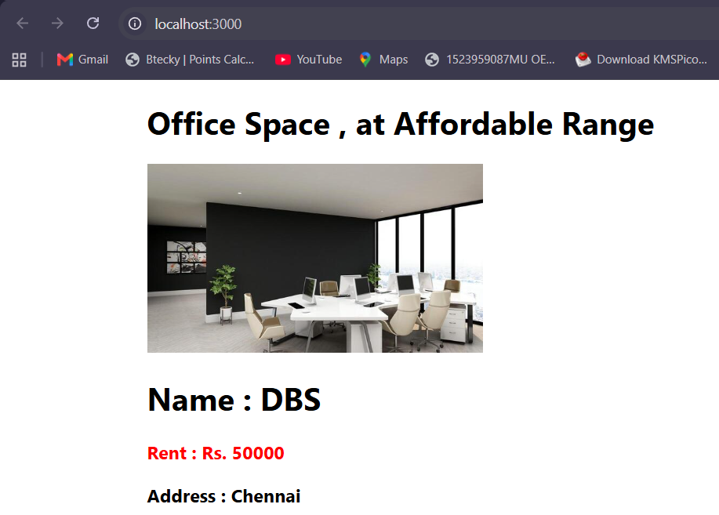

React Lab-11:
Create a React Application “eventexamplesapp” to handle various events of the form elements in HTML.
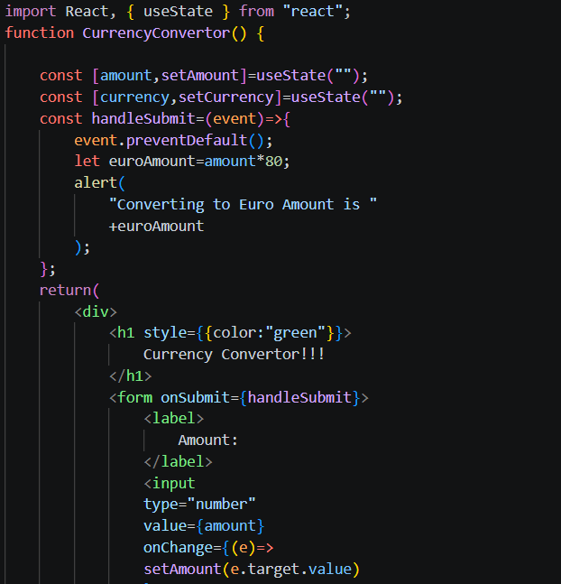
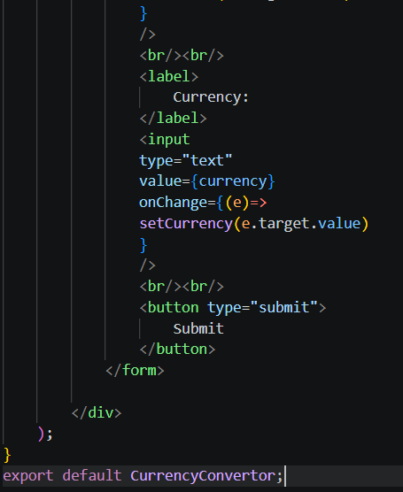

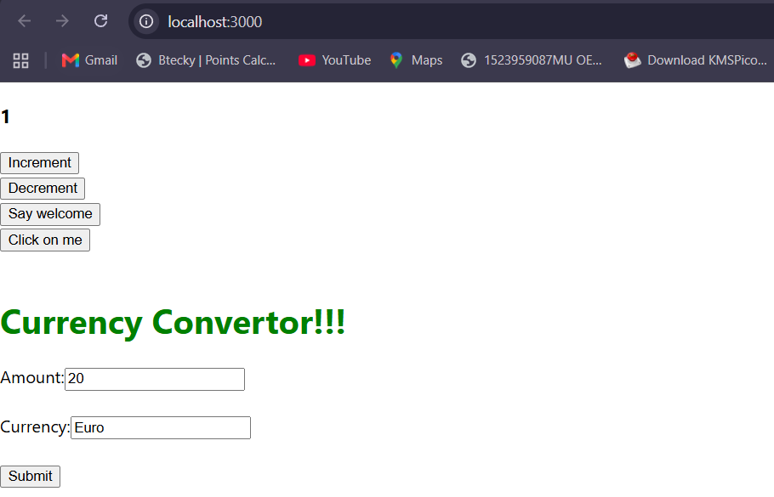

React Lab-12:
Create a React Application named “ticketbookingapp” where the guest user can browse the page where the flight details are displayed whereas the logged in user only can book tickets.
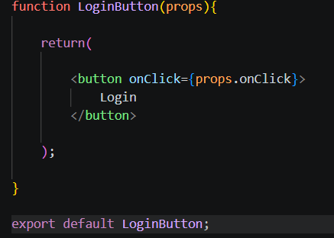
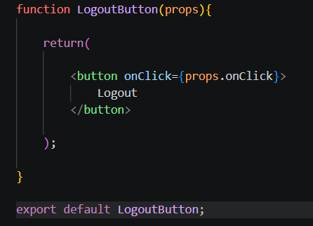
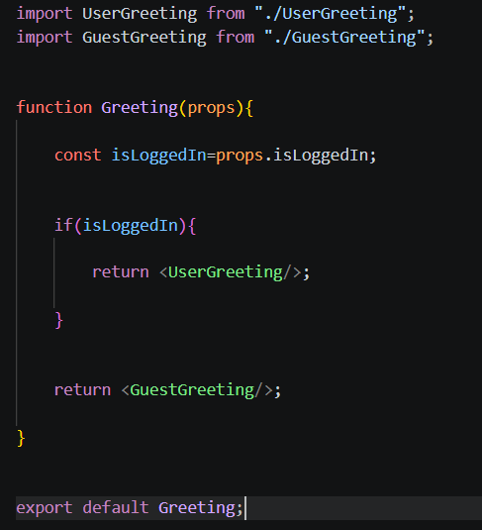
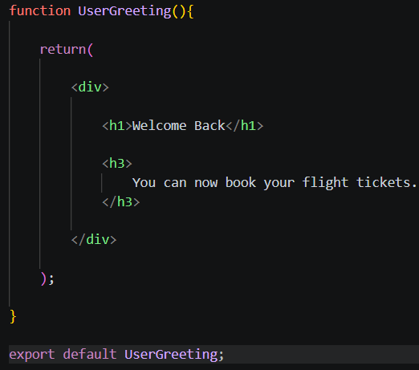
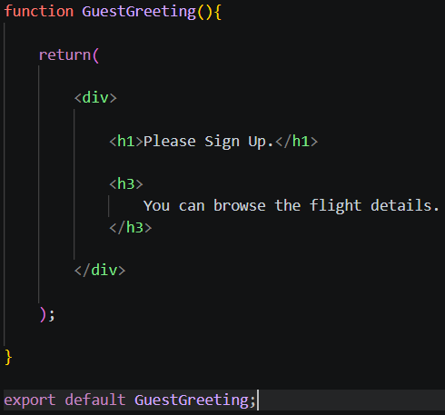

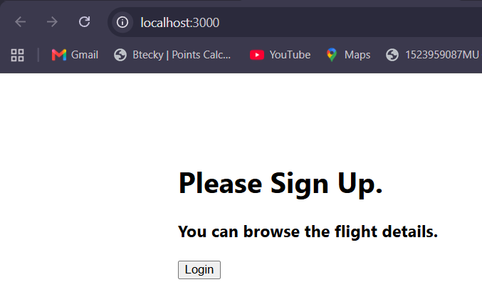
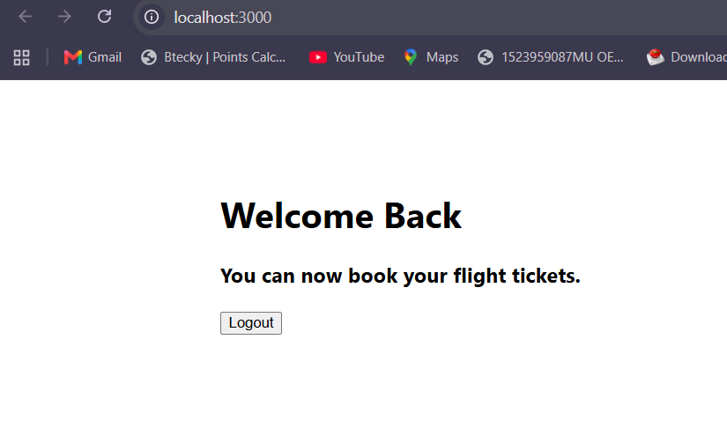

React Lab-13:
Create a React App named “bloggerapp” in with 3 components.
- Book Details
- Blog Details
- Course Details
Implement this with as many ways possible of Conditional Rendering.

